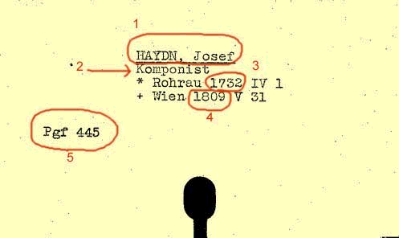
Example 1: Header Card (Person)
- Main Heading
- Profession
- Date of Birth
- Date of Death
- Persons‘ index code

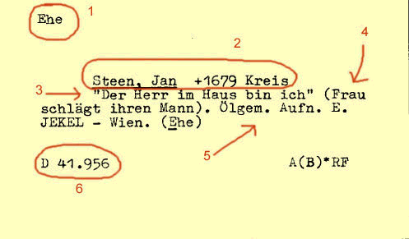
Example 2: Index card (subject)
- Main heading
- Second heading
- Legend
- Description
- Technique
- Signature

Example 3: Pointer card (subject)



Example 4: Header card (topography)
1. place name
2. federal province
3. district authority
4. geographical area codes

Example 5: Index card (topography)
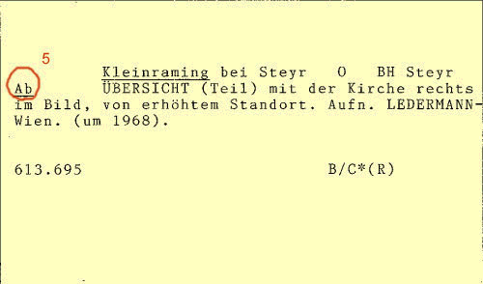
5. classification scheme

